**PROJECT DESIGN PHASE-I**

**PROBLEM SOLUTION FIT**

|  |  |
| --- | --- |
| **Date** | 31-10-22 |
| **Team ID** | PNT2022TMID12291 |
| **Project Name** | Smart Farmer-IOT Enabled Smart Farming Application |

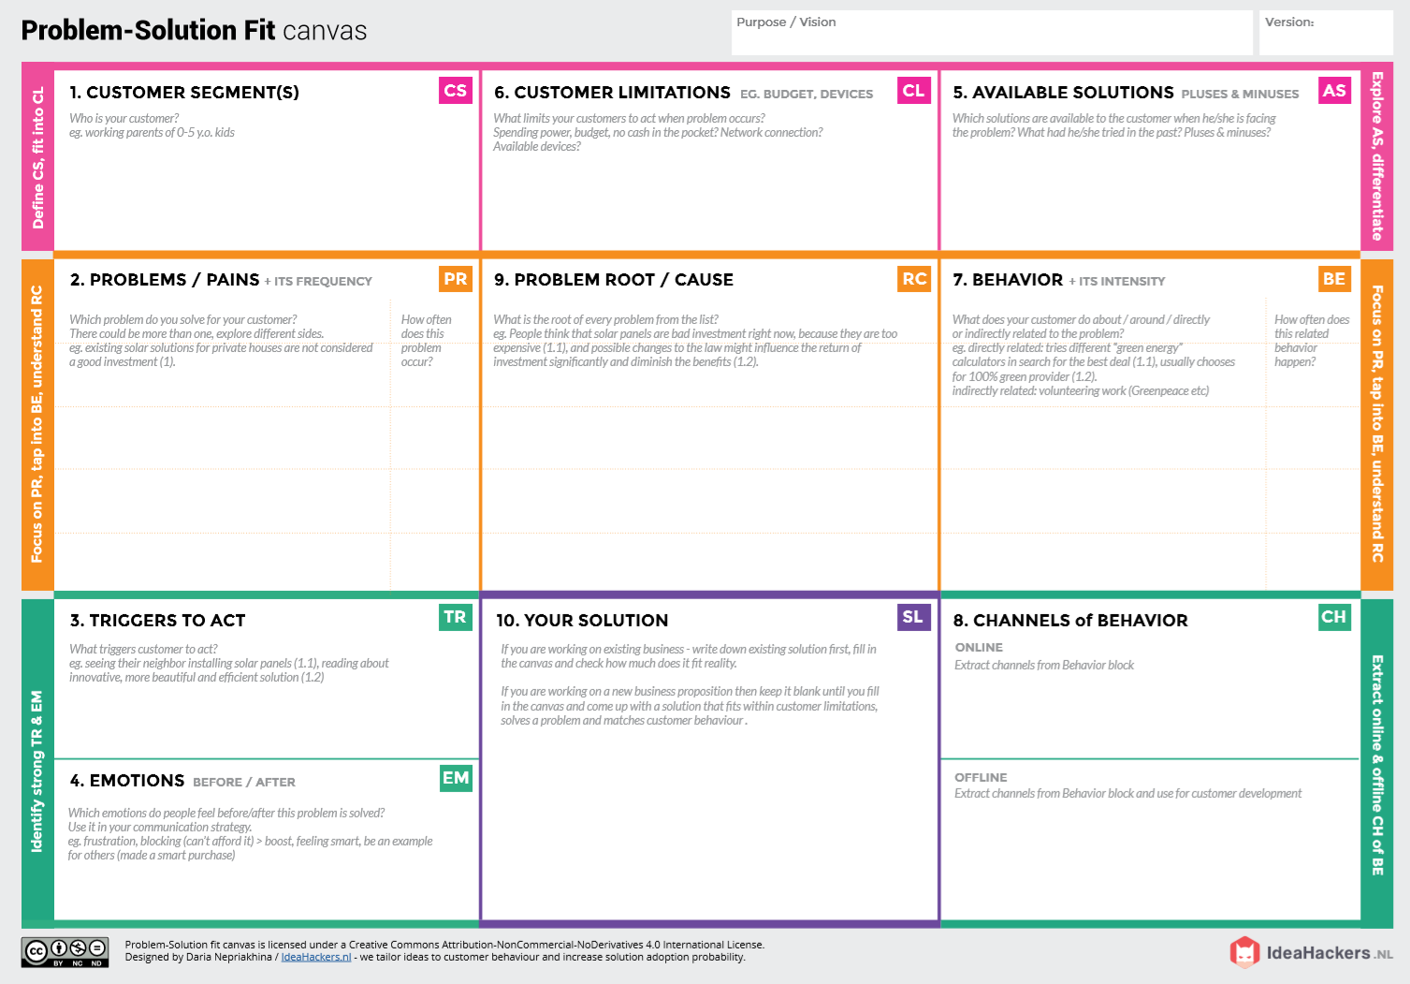­­­­

**BEFORE**: Lack of knowledge in weather and water ph level monitoring

**AFTER**: data from reliable source

Farmers facing issues in production of crops because of change in climate, temperature humidity farmers are struggle to predict the weather

This application focuses on water level monitoring use of less hazardous pest soil ph level monitoring



**OFFLINE**: People attempt to diagnose diseases based on the condition of the levels

**ONLINE:** Basic understanding of pests quality ,soil quality through the application

By making Farming more connected and intelligent ,precision agriculture helps reduce over all costs and improve the quality of product

1)If temperature, PH level, humidity & light intensity makes the serious cause for the environment.

2)Farmer affected by less productivity which will affect in their profit and production of source.

**Directly:** The tools make the farmers comfortable to monitor the water and soil ph level , pest level and weather.

**Indirectly:** online results may be accessed instantly by farmers, who can also except good growth of crops.

Monitor different parameters and mobile or web application make easily to farm the crop field.

Deployment of huge number of sensors is difficult .It requires a unlimited or continuous internet connection to be successful

Large land owners and farmers are the target customers